Sometimes you need to register your database as an ODBC data source. To do this, open the ODBC Data Source Administrator.

1. Clink on the start menu icon and type ‘odbc’ into the handy search bar on the bottom.

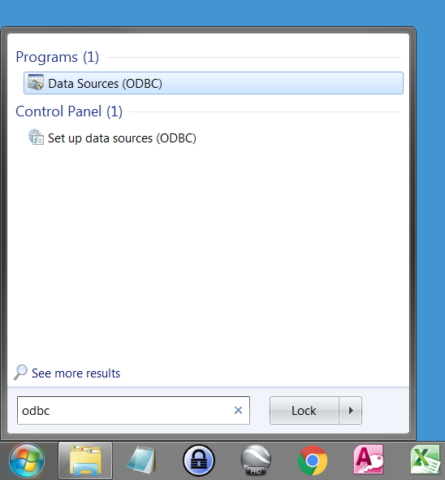

1. Open ‘Data Sources (ODBC)’
2. Click on the ‘Add…’ button to add the database to the User Data Sources list.

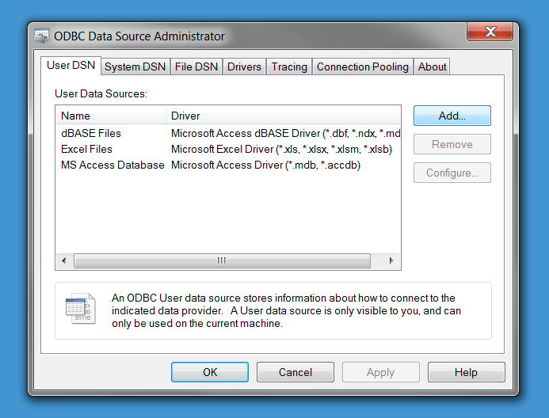

1. Select Microsoft Access Driver (\*.mdb, \*.accdb), the second from the top.

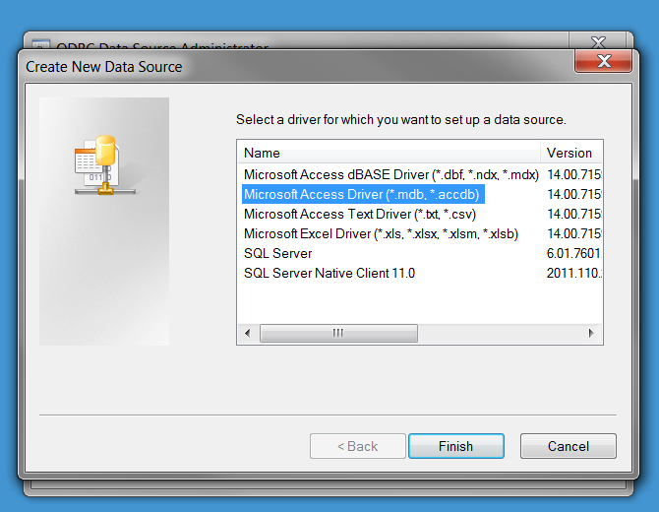

1. In the next window, give your database a name and hit the ‘Select…’ button.

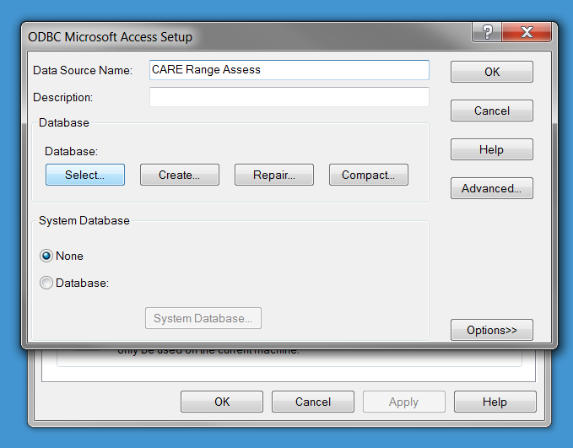

1. Then navigate to your database.
   1. You might need to select the drive from the Drives dropdown menu.

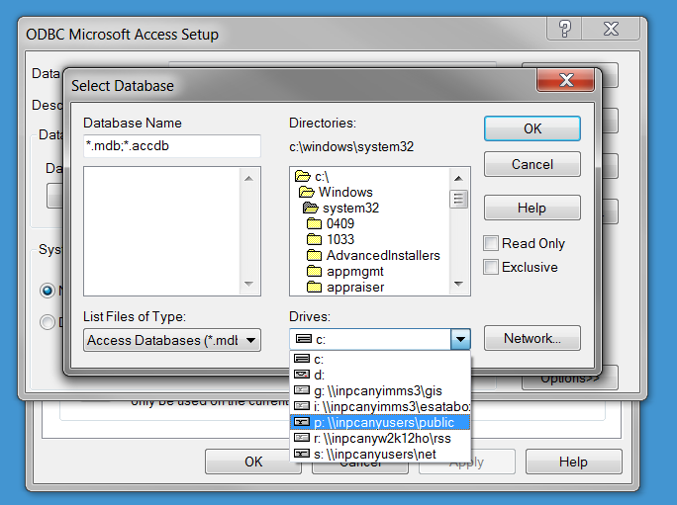

* 1. Then use the Directories pane to navigate to the directory that your database is located in.
  2. The database will show up in the left most pane, under Database Name.
  3. Once selected, hit ‘OK’.

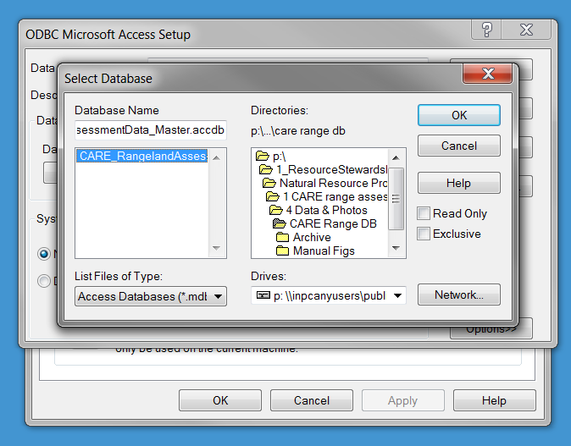

1. Click on ‘OK’ on the main window and there you go.
2. Now restart your computer and you should be off to the races.